**Docker Basic Commands** 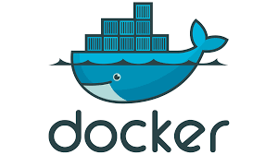

**docker-compose**: used for configuring and starting multiple Docker containers on the same host–so you don't have to start each container separately.

**docker-compose scale <service name> = <no of instances>:** sets the number of containers to run for a service

**docker-compose ps**: lists all the running containers

**docker-compose down**: shuts down all the running containers

**docker-compose logs:** used to get all the logs related to the container

**docker pull:** pulls an image from docker hub

**docker push:** pushes an image to the docker hub repo.

**docker start:** starts the container

**docker stop:** stops the container

**docker rm:** removes/delete the container